Texture Guide
- If you want the color in Substance painter looks almost consistent to the color in Unreal, you need to follow the steps below
Step1: Download the PFE_TechArt from Github
Step2: Open SP through double-clicking Substance Painter.bat (the .bat file will help config the color profile automatically, it only needs to be set up the first time; no further setup is required afterward)
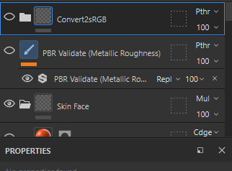
(branch 1) You open sp through Substance Painter.bat: drag this smart material on top of the layers when you export textures (only enable it when you export textures, don't enable it when you observe it)
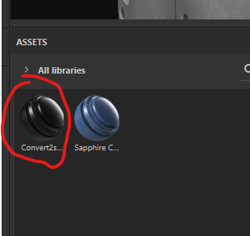
(branch 2) You open sp through default ways (icon/.exe): You need to change import and export color space.2
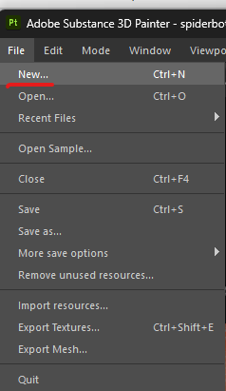
(new… for new project, Project Configuration… for existed project)
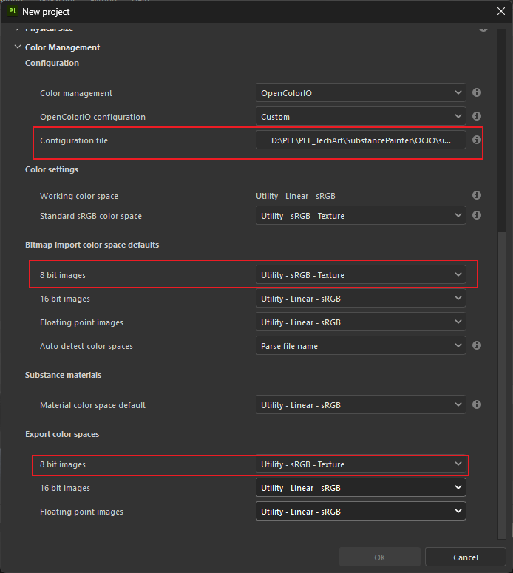

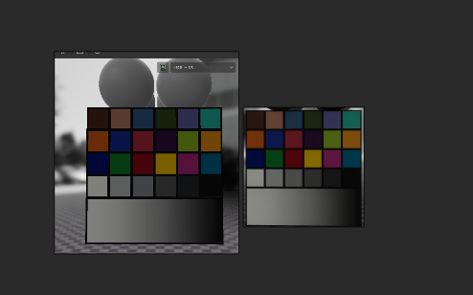
(the left one is in Substance Painter, the right is in Unreal Engine. They are almost the same, it’s hard to get exactly the same look because the postprocess and other settings)
- Use PBR checker
This setting is used for both metal and non-metal, you can choose “Albedo” for non-metal or “Metal” for metal.
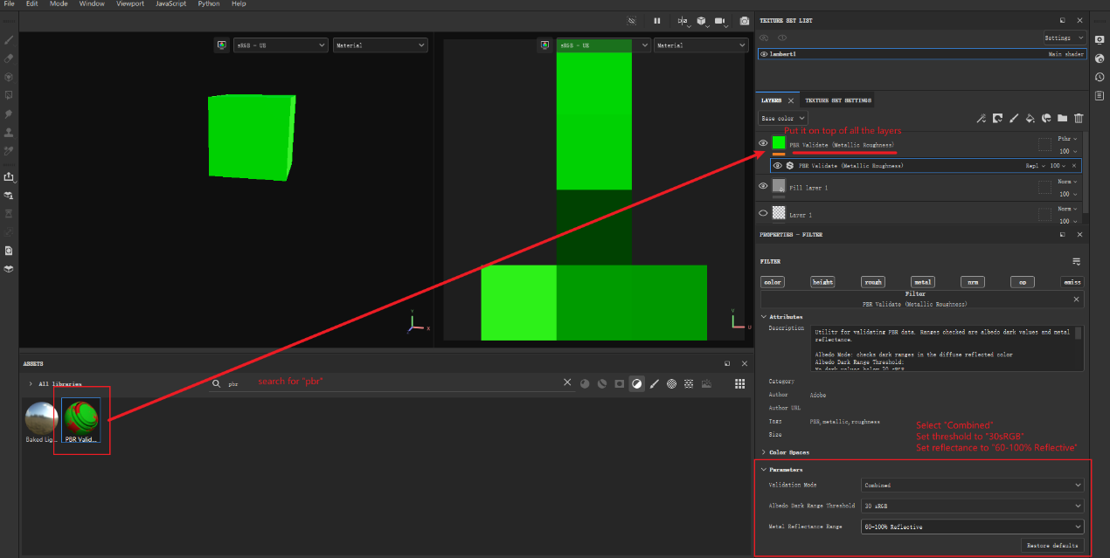
- Export textures
select correct “Output directory” and “Output template”
check the list of exports
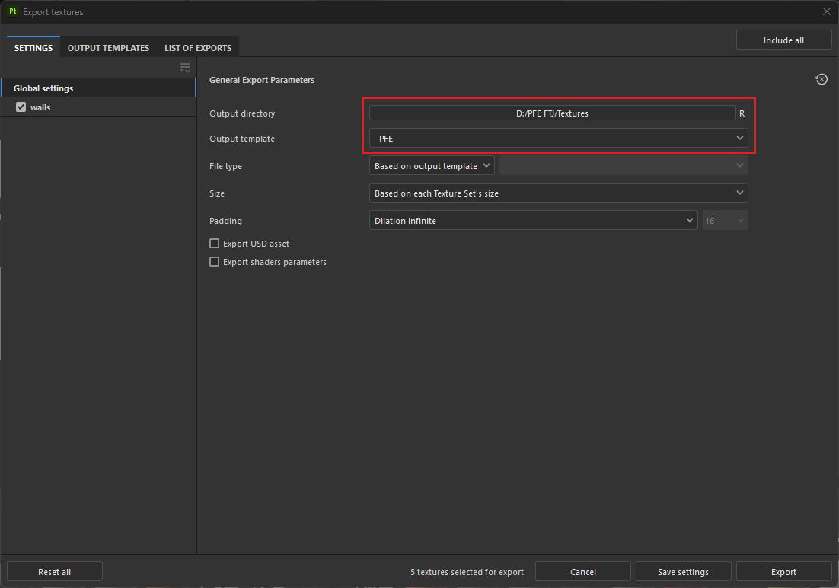
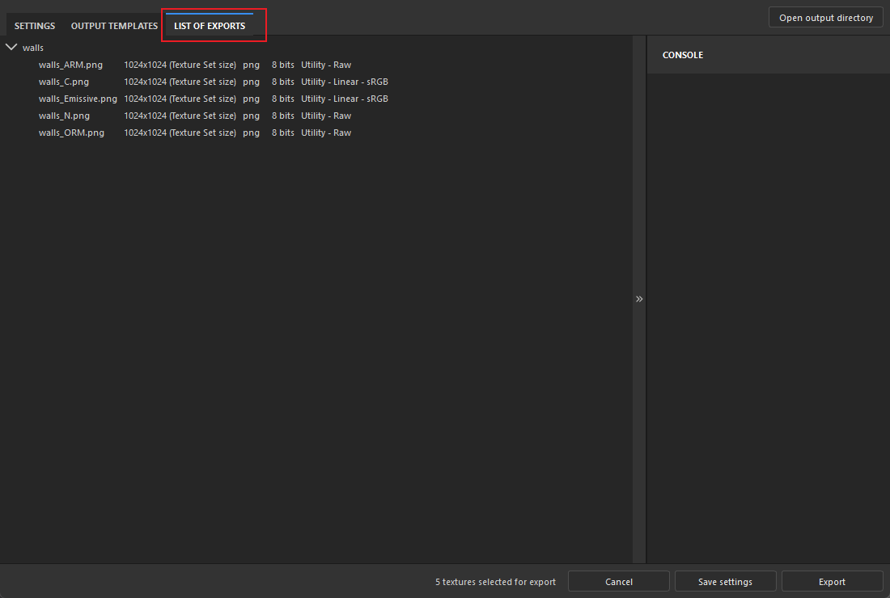
- Import textures
Since we are using SVT(streaming virtual texture), we need to convert regular textures to virtual textures for all environment assets.

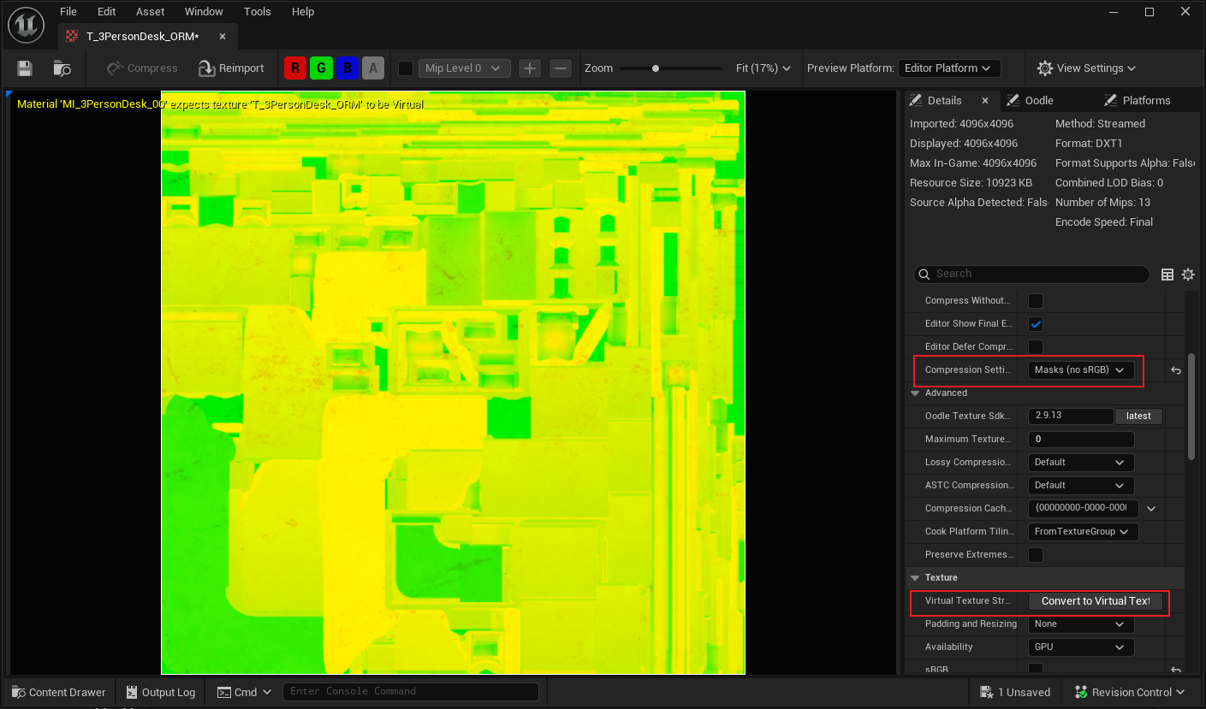
Uncheck sRGB and change Compression Settings to Masks (no sRGB) for _ORM textures
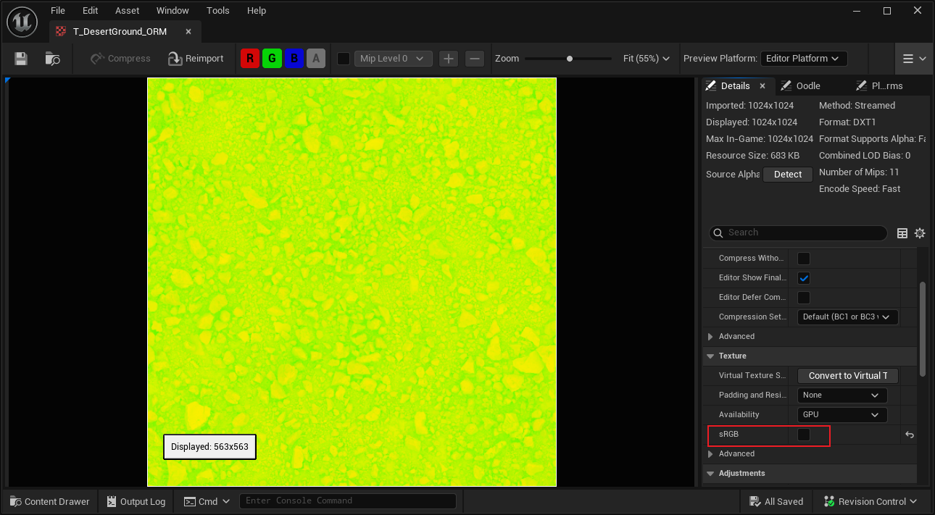

- Check assets in Unreal Engine Lookdev
Lookdev path: /Game/LookDev/DataPrepViewMain.DataPrepViewMain

Additional tips:
- use BC7 compression on texture with Alpha channel

